**DAILY ONLINE ACTIVITIES SUMMARY**

|  |  |  |  |  |  |  |  |  |
| --- | --- | --- | --- | --- | --- | --- | --- | --- |
| **Date:** | **06/07/2020** | | | | | **Name:** | **RITIKA R KULKARNI** | |
| **Sem& Sec** | **4​th​ SEM. & ‘B’ SEC.** | | | | | **USN:** | **4AL19CS403** | |
| **Online Test Summary** | | | | | | | | |
| **Subject** | | **Complex Analysis, Probability and Statistical Methods** | | | | | | |
| **Max. Marks** | | **30** | | **Score** | | | **- -** | |
| **Certification Course Summary** | | | | | | | | |
| **Course** | **Introduction of Data Analysis** | | | | | | | |
| **Certificate Provider** | | | **Leapsapp** | | **Duration** | | | **7 Hrs.** |
| **Coding Challenges** | | | | | | | | |
| **Problem Statement:**   1. **Write a Java program to find the Nth natural number with exactly two bits set.** | | | | | | | | |
| **Status: Executed** | | | | | | | | |
| **Uploaded the report in Github** | | | | | **Yes** | | | |
| **If yes Repository name** | | | | | <https://github.com/ritikakulkarni> | | | |
| **Uploaded the report in slack** | | | | | **Yes** | | | |

**Online Test Summary:**  Today 1MAT41 Descriptive test was conducted there were three questions the test was from 9:30 am to 10:15 am .

**Online Certification course Summary​:** I have taken new Online Certification Course in **leapsapp** . Today I went through Fundamentals of Data Analysis.

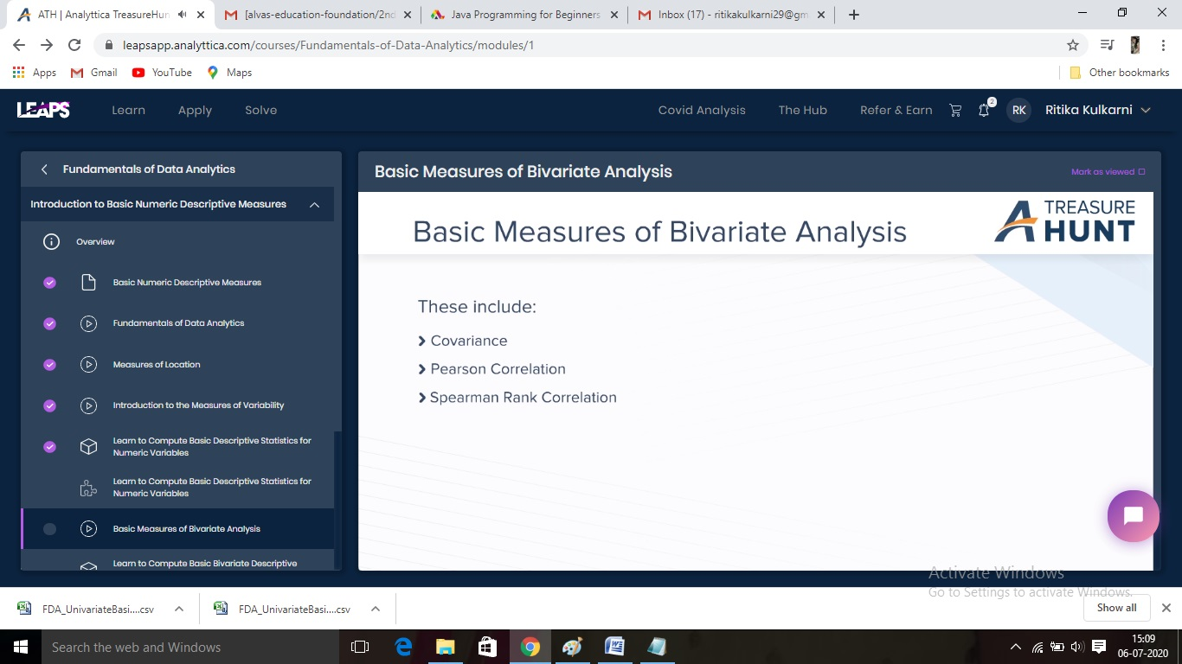

**Online Coding Summary​:Today I received one program from Prof. Vasudev sir CSE Dept.. I have written one program and uploaded it to my Github repository. This is my repository snapshot. I have uploaded the frequency program.**

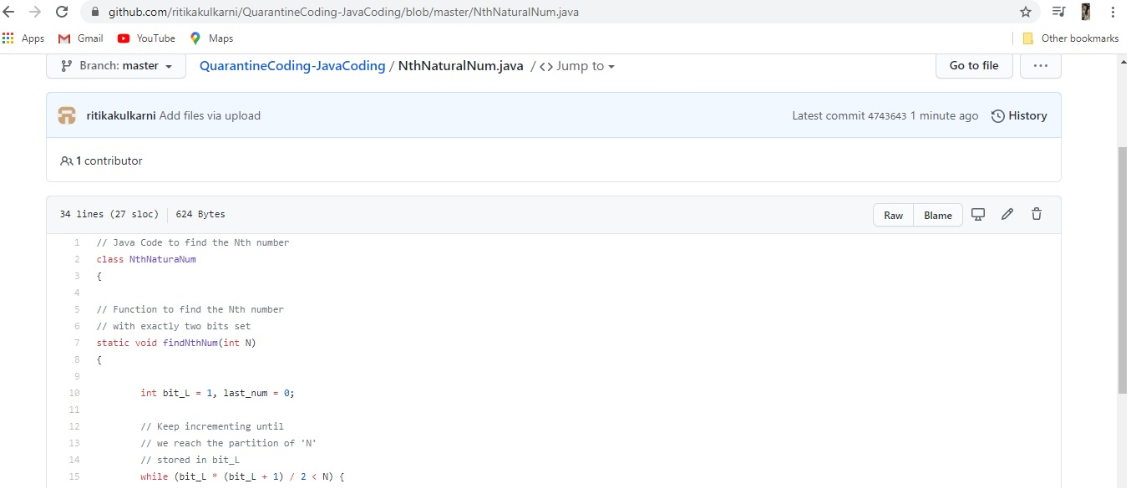

Thank you